Hong Kong’s History

Hong Kong was a British colony for about 150 years, which means that the British regent ruled Hong Kong. These 150 years is a very important part in Hong Kong’s history not least for Hong Kong’s development as an trade centre and its economic growth. Hong Kong was Britains only port in the Far East; it meant that everything that Britain bought and sold to China went through Hong Kong. In a few years Hong Kong grew from a little unknown port town in 1848, (when the British Empire conquered the town), to one of the biggest and most important city in the world to in the late 19th century.
The years under the British regents has given this town a very special atmosphere that you can’t find elsewhere in the world, it is a mix between old and new. First we have the poor suburbs of Hong Kong who is crowded with small one-storied houses made of wood and paper !? Then we have the inner parts of Hong Kong who is filled with modern skyscrapers rising hundreds of meters in the air.
Hong Kong is built in a valley with a bay in the middle and now as the city grows there is now space. The first inhabitants who moved to the location where Hong Kong is today could surely not imagine that 2000 years later there would live about 6 million people! So if for them there was enough space, that is not the case today.
Many people suggest that they should remove the low houses including the suburbs to make place for higher buildings, but then they will face a new problem, where should the people in the suburbs live then? They are to poor to afford a flat in the new houses. Because of the terrain Hong Kong doesn’t have so many industries, except for the textile production and the manufacturing of digital circuits. Otherwise there are mostly large banks, investors, Computer business and large companies headquarters who are stationed here because of the prices compared to those in the west.
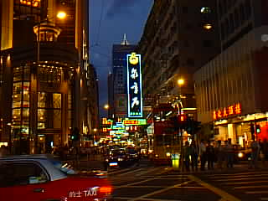
As I have already mentioned before Hong Kong was a British colony and by that I mean was. In 1997 Britain returned Hong Kong to China because of an agreement that was written in 1898 who said ”the British Empire should return Hongkong to its original owners in 99 years from now”.
Many people believe that this will effect Hong Kong economy and it’s citizens bad. Therefore the Chinese Communist government has agreed to keep the British economical system for 50 years.

